Thomas Willingale School and Nursery:
Maths Progression Map
Years 1-6

We broadly follow the White Rose timetable (Years 1-6) and have adapted their progression document according to our own programme of teaching.
Years 1- 6 timetables are included, after the progression map.
EYFS follows the EYFS Development Matters Statements.

EYFS Development Matters 2020 Statements Three and Four-Year-Olds - Specific Areas
Mathematics
• Develop fast recognition of up to 3 objects, without having to count them individually (‘subitising’).
• Recite numbers past 5.
• Say one number for each item in order: 1,2,3,4,5.
• Know that the last number reached when counting a small set of objects tells you how many there are in total (‘cardinal principle’).
• Show ‘finger numbers’ up to 5.
• Link numerals and amounts: for example, showing the right number of objects to match the numeral, up to 5.
• Experiment with their own symbols and marks as well as numerals.
• Solve real world mathematical problems with numbers up to 5. • Compare quantities using language: ‘more than’, ‘fewer than’.
• Talk about and explore 2D and 3D shapes (for example, circles, rectangles, triangles and cuboids) using informal and mathematical language: ‘sides’, ‘corners’; ‘straight’, ‘flat’, ‘round’.
• Understand position through words alone – for example, “The bag is under the table,” – with no pointing.
• Describe a familiar route.
• Discuss routes and locations, using words like ‘in front of’ and ‘behind’.
• Make comparisons between objects relating to size, length, weight and capacity.
• Select shapes appropriately: flat surfaces for building, a triangular prism for a roof etc.
• Combine shapes to make new ones – an arch, a bigger triangle etc.
• Talk about and identifies the patterns around them. For example: stripes on clothes, designs on rugs and wallpaper. Use informal language like ‘pointy’, ‘spotty’, ‘blobs’ etc.
• Extend and create ABAB patterns – stick, leaf, stick, leaf.
• Notice and correct an error in a repeating pattern. • Begin to describe a sequence of events, real or fictional, using words such as ‘first’, ‘then...’

EYFS Development Matters 2020 Statements Children in Reception - Specific Areas

Mathematics
• Count objects, actions and sounds.
• Subitise. • Link the number symbol (numeral) with its cardinal number value.
• Count beyond ten.
• Compare numbers.
• Understand the ‘one more than/one less than’ relationship between consecutive numbers.
• Explore the composition of numbers to 10.
• Automatically recall number bonds for numbers 0-5 and some to 10.
• Select, rotate and manipulate shapes to develop spatial reasoning skills.
• Compose and decompose shapes so that children recognise a shape can have other shapes within it, just as numbers can.
• Continue, copy and create repeating patterns. • Compare length, weight and capacity
 |  |  |  |  |  | 
 | •           •                | •          | •            | •  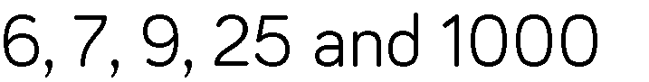  •          | •           •            | - Revision of previous learning  Autumn 1
 | •         •       •       | •        •            | •  •       | •  •              | •           •         | •      

 | •      | •         •        | •      • | •       •        •      | •    | •          
 |  | •      | •        | •     •          | •     •           •   | •       •        •  

 | •           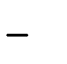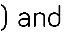    •            | •             •               •                 Autumn 1 | •          | •       | •          







 | •         | •           ➢    ➢    ➢  ➢ | •      ➢  ➢  ➢    •           | •         | •              •     | •        •           





 | •          □ | •     ➢           ➢        | •            | •              | •    •                    | •

 |  | •    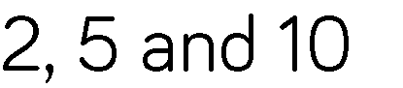        •            | •  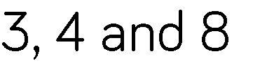   | •       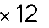  •                 •        | •            •             •           •        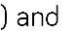   | •      •         





 |  | •         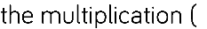  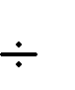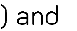 | •                  | •         | •               •       •                 •           | •              •                •            •

 | •                 | •                 | •               | •                 | •            •       | •  
 |  |  |  |  | • | •

























































 | •           •           | •  1 , 1 , 2 3  3 4 4 4 | •  •  • | •               | •  •  2 + 4 = 6 =  5 5 5  1 1  5
 |  | •  2  4  1  2 | •  • | •        | •         | •             •    



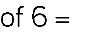
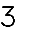

















 |  | •  1  2 | •  5 + 1 = 6  7 7 7 | •   | •        •            | •  •  1 × 1 = 1  4 2 8  •  ¹ ÷ 2 = 1  3 6
 |  |  | •      | •              














 |  |  |  | •  •  1 , 1 , 3  4 2 4 | •  71  100  • | •       
 |  |  |  | •       •          | •        •   


 |  |  |  | •                  | •     | •        •      •         •       





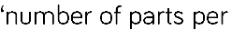
















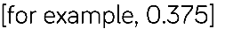

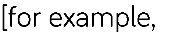








 |  |  |  | •        | •  •  1 , 1 , 1 , 2 , 4  2 4 5 5 5 | •  3  8  •

 |  |  |  |  |  | •              •                    •          •          





 | •                  □ | •              | •      |  |  | •   •      •       •         •       


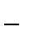
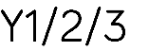

 |                                     •       ➢             ➢         ➢         ➢       •     ➢   ➢   ➢   ➢      | •  ℃  • | •           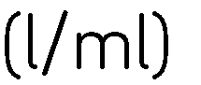 | •            •       Spring 1   | •              •               •                | •              •                           •  

 | •        | •            •         •                | •         | •       | •  

 | •                 •          •          | •       •               •         Summer 4 | •              •                         •        •          | •      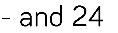  •             | • | •          

 |  |  | •      | •   • | •  •  • | •  •  •  •

 | • | •  •  •  Summer 4 | • | •  • | •  • | •  •  •
 | • | •  •  Summer 4 | • |  | • | •

 |  |  | •  •  • | •  •  • | •  •  •  ➢  °  ➢  1  2  °  ➢  ° | •  •

 | • | •  •  Summer 5 |  | •  •  • | • | •  •

 |  | • | • | • | •  Summer 1 | •
 |  | •  • | • | • | •  Summer 1 | •





